Tring Lions Quiz (9)
. 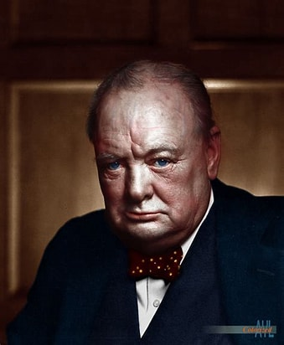
Prime Ministers
Presidents
and Poets
The answers to the 50 cryptic clues are the surnames (or aristocratic titles) of famous people. There are 27.5 UK Prime Ministers, 16.5 American Presidents and 6 English poets
For this quiz, to add to the excitement, we are offering prizes for the most correct answers, £20, £10 and £5. Equal scores will be drawn out of a hat
Please email your answers to Penny.tregillus@tringlions.org.uk or post them to Penny Tregillus, 33A Rock Lane, Leighton Buzzard, LU7 2QQ
Answers will be published on our website www.tringlions.org.uk on Wednesday 1st March
The charity we will be supporting with this quiz is ‘Small Acts of Kindness’.
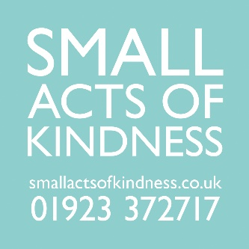
‘Small Acts of Kindness sources and distributes practical gifts and information that reduce the negative impact that feeling lonely and isolated can have on older people’s physical and mental wellbeing. We have a particular interest in reaching older people who are cold in their homes. Our aim is that every older person feels warm in their home and better connected to their community. We connect communities with kindness’.

If you enjoyed the quiz and would like to make a donation you can either:

Do a bank transfer to Tring Lions Club Sort code: 40-44-32 Account: 51419226

Go to our website www.tringlions.org.uk and press the ‘Donate’ button.

Or, if you want to feel part of the modern age, and you have the necessary equipment and expertise, you can scan this QR
Code.

If you are a tax payer and would like to Gift Aid your donation a declaration form is available on our website, when completed this should be sent to mike.adams@tringlions.org.uk.
Please feel free to circulate the quiz to anyone you think might be interested.
Good luck and thank you for your support
Tring Lions Quiz (9)
.
Prime Ministers
Presidents
and Poets
The answers to the 50 cryptic clues are the surnames (or aristocratic titles) of famous people. There are 27.5 UK Prime Ministers, 16.5 American Presidents and 6 English poets
1 | Process required to fill a tin with baked beans (7)
2 | Forerunner of a Dyson maybe (6)
3 | Start of clue, flat and and (9)
4 | What one is always thinking about when playing scrabble (10)
5 | Old mother has a degree (5)
6 | Perhaps he had a house on the Isle of Man (7-4)
7 | Canadian emblem is scattered around the centre (6)
8 | Ecclesiastical building is not in good shape (9)
9 | A rather large number of clothes needing the laundry (10)
10 | Need to sort out those bits on the lego stand (9)
11 | Nine surrounded by nothing (5)
12 | A President or a Prime Minister. An offspring of Kennedy perhaps (7)
13 | Perhaps his greatest legacy was helping us to keep our feet dry (3 4 2 10)
14 | Perhaps his greatest legacy can be found in a pot of tea (4 4)
15 | Middle eastern person follows the start of day (8)
16 | Hampstead for example (5)
17 | Need to be shaken up (4)
18 | The night before, Lieutenant follows Australian animals (9)
19 | Look at him smoking that cheroot (8)
20 | No right when arranging arrange (6)
21 | Warning light! start looking in 22 yards (11)
22 | Sounds like you're saying goodbye to Reagan maybe (5)
23 | Mother looks at Diana’s onion skin (7)
24 | Stir the milky coffee and start eating (6)
25 | Person waving placard advertising soup perhaps (8-9)
26 | Take a bit of old cloth back to a meadow (8)
27 | Greek character is on the wagon (4)
28 | A particular shade of environmentalist (7)
29 | Old aeroplane ahead of friend and comedian Paul eating first sweet (8 10)
30 | Leave amongst the remains of a fire (7).
31 | Could be a winning card for a bridge player (5)
32 | He makes exceedingly good cakes (7)
33 | Sort out what happens to a bicycle, perhaps, when left out in the rain (5)
34 | For starters Betty likes an Italian risotto (5)
35 | Corpulence coming back belonging to us (7)
36 | Sounds like a Scottish mountain (6)
37 | Not quite a Lieutenant Colonel but a bit better than a Captain (5)
38 | Tin contains everything with a tough ending (9)
39 | Cook sirloin perhaps (5)
40 | And I in Paris get involved in what sounds like an apiarist (8)
41 | Raincoat and indefinite article protect grinder (9)
42 | Sonny is tangled in net (8)
43 | Trick wrapping round a first aid wrapping (7)
44 | Twist arm into a cone shape (7)
45 | You need to investigate why they forbid English (5)
46 | Victory for Yul Bryner (or Mahatma Gandhi) (7)
47 | Scottish version of Disney character (9)
48 | Confused! nowhere to go on last half of cruise (10)
49 | Transport to the first hotel (4)
50 | Paddle from one side of Britain to the other (5)

