Tring Lions Quiz (15)
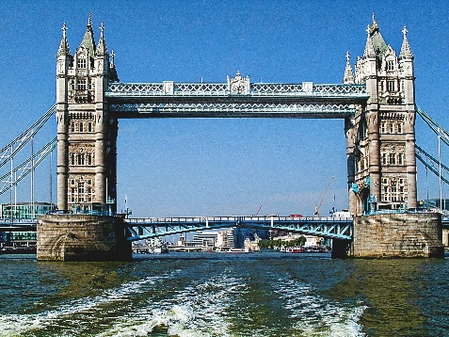
A Capital Quiz
In this quiz there are 50 clues, the answers to 25 of them are the names of Capital cities and the answers to the other 25 are the corresponding countries.
So, solve one clue and your halfway to solving another one. To add to the excitement, we are offering prizes for the most correct answers, £20, £10 and £5. Equal scores will be drawn out of a hat.
Please email your answers to Penny.tregillus@tringlions.org.uk or post them to Penny Tregillus, 33A Rock Lane, Leighton Buzzard, LU7 2QQ
Answers will be published on our website www.tringlions.org.uk on 31st July 2026
The charity we will be supporting is Carers in Hertfordshire and its work with young carers. 
‘The charity provides free help for Hertfordshire’s unpaid carers - children and adults caring for someone with an illness, disability, or other need - so they are identified, supported, and heard. Services include advice, mentoring, groups, and workshops. Young carers often juggle education, their health, and caring. We provide them with activities offering vital breaks from a caring role and opportunities to share their views and shape services.’
If you enjoyed the quiz and would like to make a donation to support Carers in Hertfordshire you can either; send a cheque, payable to Tring Lions, to Penny (see address above); or do a bank transfer to: Tring Lions Club CIO Sort code: 23-05-80 Account: 49391625; or go to our website www.tringlions.org.uk and press the ‘Donate’ button; or scan this QR code




If you are a taxpayer and would like to Gift Aid your donation, a declaration form is available on our website, when completed this should be sent to mike.adams@tringlions.org.uk.
Please feel free to circulate the quiz to anyone you think might be interested.
Good luck and thank you for your support
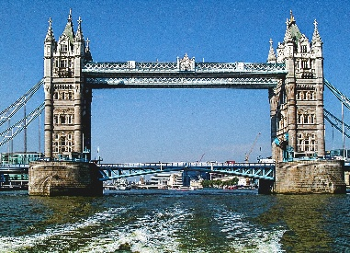
A Capital Quiz
So here are your clues for the 25 capitals and the 25 countries.
1 | Where Dionne Warwick is going to (3 4)
2 | This can be a statement about a posh car (8)
3 | Where Satchmo may have moored his boat? (4 5)
4 | Sounds like you need to check about somewhere that’s not private (5 8)
5 | Maureen's farmyard animal (6)
6 | Put the bag back on (5)
7 | A wobbly line flows through here (5)
8 | Diva sings a solo about her male admirers? (7)
9 | A monarch and a good person working together (8)
10 | A Frenchman begins to look away from the sea (7)
11 | The Public Relations department is getting quite feverish (6)
12 | Seaborne section of armed forces goes back around how a cockney may tell you where he is (7)
13 | It's very simple all you need is a bit of a hug and a kiss (6)
14 | What a wonderful, wonderful place this is (10)
15 | Sounds like what you may ask an artist standing by a sculpture of a lady (7)
16 | Look into how the sheriff ran certain prisons (6)
17 | The slippery sound of a musical (6)
18 | Fawlty maybe gets confused on air (8)
19 | Sounds like a cow shed (9)
20 | To start with I ran away quickly (4)
21 | Yellow bricks will show you the way here (9)
22 | They are proud to have made George cross (5)
23 | Boleyn maybe returns after 6 (6)
24 | There's no right way to go here (6)
25 | I join the links but miss out on the tea (8)
26 | The toilets are a bit confusing (4)
27 | Free French town (10)
28 | Kay, a politician, is left in the middle of alcoholics anonymous (7)
29 | A good start would be to visit a financial establishment that is alright (7)
30 | Sounds like a country where formal menswear is the status quo (8)
31 | I'm in a vehicle heading towards nothing (5)
32 | Move market garden around and look at what's inside (7)
33 | Feeling peckish? (7)
34 | Remove a learner from another country (7)
35 | Where to go for a coffee? Eric Allen's inside (5 4)
36 | Artificial intelligence looking back towards boat following game (6)
37 | Elizabeth shortly goes back behind supporter (6)
38 | Open out and take a wobbly step (8)
39 | You must look at certain diamonds to get the answer (5)
40 | Almost sounds like an example of what you may find in Punch magazine (8)
41 | Film of a second world war general? (10)
42 | Look back on how Alan Pollard could be addressed after being knighted (5)
43 | You have to get mixed up with tiramisu (9)
44 | Head southwest to visit this 'stunning botanical attraction' (6)
45 | Swap a shilling for a penny in this lethargic means of distributing food around the table (5)
46 | Gee, why are you to use a mixture? (7)
47 | Wrap father up? (7)
48 | Indefinite and definite articles head in different directions (6)
49 | Manservant gets left and says thank you (8)
50 | Sounds like we are going to a new food shop (3 5)

