Tring Lions Quiz (15)
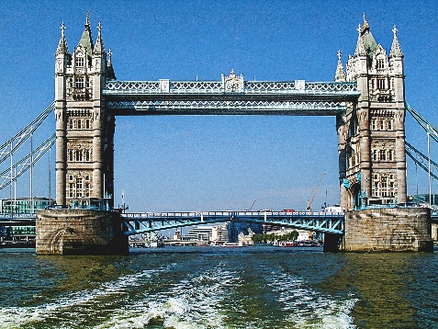
A Capital Quiz
In this quiz there are 50 clues, the answers to 25 of them are the names of Capital cities and the answers to the other 25 are the corresponding countries.
So, solve one clue and your halfway to solving another one. To add to the excitement, we are offering prizes for the most correct answers, £20, £10 and £5. Equal scores will be drawn out of a hat.
Please email your answers to Penny.tregillus@tringlions.org.uk or post them to Penny Tregillus, 33A Rock Lane, Leighton Buzzard, LU7 2QQ
Answers will be published on our website www.tringlions.org.uk on 31st July 2026
The charity we will be supporting is Carers in Hertfordshire and its work with young carers. 
‘The charity provides free help for Hertfordshire’s unpaid carers - children and adults caring for someone with an illness, disability, or other need - so they are identified, supported, and heard. Services include advice, mentoring, groups, and workshops. Young carers often juggle education, their health, and caring. We provide them with activities offering vital breaks from a caring role and opportunities to share their views and shape services.’
If you enjoyed the quiz and would like to make a donation to support Carers in Hertfordshire you can either; send a cheque, payable to Tring Lions, to Penny (see address above); or do a bank transfer to: Tring Lions Club CIO Sort code: 23-05-80 Account: 49391625; or go to our website www.tringlions.org.uk and press the ‘Donate’ button; or scan this QR code




If you are a taxpayer and would like to Gift Aid your donation, a declaration form is available on our website, when completed this should be sent to mike.adams@tringlions.org.uk.
Please feel free to circulate the quiz to anyone you think might be interested.
Good luck and thank you for your support
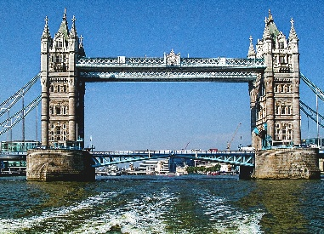
A Capital Quiz
So here are your clues for the 25 capitals and the 25 countries.
1 | Where Dionne Warwick is going to (3 4) | San José
2 | This can be a statement about a posh car (8) | Canberra
3 | Where Satchmo may have moored his boat? (4 5) | Port Louis
4 | Sounds like you need to check about somewhere that’s not private (5 8) | Czech Republic
5 | Maureen's farmyard animal (6) | Moscow
6 | Put the bag back on (5) | Gabon
7 | A wobbly line flows through here (5) | Egypt
8 | Diva sings a solo about her male admirers? (7) | Armenia
9 | A monarch and a good person working together (8) | Kingston
10 | A Frenchman begins to look away from the sea (7) | Finland
11 | The Public Relations department is getting quite feverish (6) | Prague
12 | Seaborne section of armed forces goes back around how a cockney may tell you where he is (7) | Yerevan
13 | It's very simple all you need is a bit of a hug and a kiss (6) | Uganda
14 | What a wonderful, wonderful place this is (10) | Copenhagen
15 | Sounds like what you may ask an artist standing by a sculpture of a lady (7) | Jamaica
16 | Look into how the sheriff ran certain prisons (6) | France
17 | The slippery sound of a musical (6) | Greece
18 | Fawlty maybe gets confused on air (8) | Brasília
19 | Sounds like a cow shed (9) | Stockholm
20 | To start with I ran away quickly (4) | Iraq
21 | Yellow bricks will show you the way here (9) | Australia
22 | They are proud to have made George cross (5) | Malta
23 | Boleyn maybe returns after 6 (6) | Vienna
24 | There's no right way to go here (6) | Norway
25 | I join the links but miss out on the tea (8) | Helsinki
26 | The toilets are a bit confusing (4) | Oslo
27 | Free French town (10) | Libreville
28 | Kay, a politician, is left in the middle of alcoholics anonymous (7) | Kampala
29 | A good start would be to visit a financial establishment that is alright (7) | Bangkok
30 | Sounds like a country where formal menswear is the status quo (8) | Thailand
31 | I'm in a vehicle heading towards nothing (5) | Cairo
32 | Move market garden around and look at what's inside (7) | Denmark
33 | Feeling peckish? (7) | Hungary
34 | Remove a learner from another country (7) | Austria
35 | Where to go for a coffee? Eric Allen's inside (5 4) | Costa Rica
36 | Artificial intelligence looking back towards boat following game (6) | Russia
37 | Elizabeth shortly goes back behind supporter (6) | Brazil
38 | Open out and take a wobbly step (8) | Budapest
39 | You must look at certain diamonds to get the answer (5) | India
40 | Almost sounds like an example of what you may find in Punch magazine (8) | Khartoum
41 | Film of a second world war general? (10) | Montevideo
42 | Look back on how Alan Pollard could be addressed after being knighted (5) | Paris
43 | You have to get mixed up with tiramisu (9) | Mauritius
44 | Head southwest to visit this 'stunning botanical attraction' (6) | Sweden
45 | Swap a shilling for a penny in this lethargic means of distributing food around the table (5) | Sudan
46 | Gee, why are you to use a mixture? (7) | Uruguay
47 | Wrap father up? (7) | Baghdad
48 | Indefinite and definite articles head in different directions (6) | Athens
49 | Manservant gets left and says thank you (8) | Valletta
50 | Sounds like we are going to a new food shop (3 5) | New Delhi

